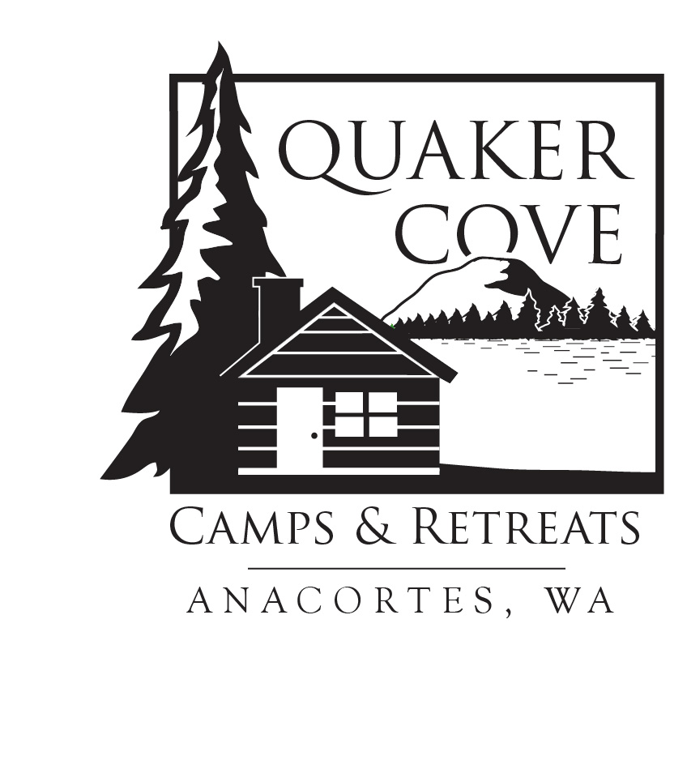QUAKER COVE DAY CAMP STAFF
OPENING DATE: January 1st
EMPLOYMENT PERIOD: July 24th-July 30th
July 31st-August 6th
August 7th-August 13th
Essential Responsibilities:
Small Group Leadership
- Teach and supervise various camp program skills: games, archery, nature exploration, crafts, etc.
- Lead Bible discussions with campers during daily share times.
- Relate to campers and volunteer counselors as a role model teaching growth in Christian character.
Large Group Involvement
- Maintain a good working relationship with fellow staff members.
- Assist Program Director and one another in leading opening times, teaching times, and closing times through song leading, skits, etc.
Program Support
- Administer first aid as needed.
- Participate in morning staff devotions and afternoon staff meetings.
- Assist with daily clean-up and maintenance of activities and facilities.
Minimum Requirements/Qualifications:
- Maintain a growing and vital relationship with Jesus Christ and exemplify that relationship in his/her daily life, including interaction with fellow summer staff, year-round staff, volunteer counselors, campers, parents, and guests.
- Be at least one year out of high school.
- Attitude of service and a commitment to ministry.
- Versatile and flexible, with the ability and interest in handling a variety of tasks.
- Ability to work effectively, creatively, and enthusiastically with a variety of ages, both children and adults.
- A love of working with children
- Dependable and consistent attitude, able to maintain self-control.
- Willingness to do minor, necessary, and sometimes dirty details.
- Good physical condition including ability to handle rugged terrain and lift 50 lbs.
- Covid-19 Vaccination is encouraged, as state requires stricter regulations for non-vaccinated staff. Must be willing to follow state regulations regarding masks and Covid-19 protocol.
Compensation: Salary dependent upon experience starting at $150 per week + Summer housing which may be on or off-site. Breakfast and lunch during Day Camps with some dinners. Bonus of $50 for 2 weeks or $100 for 3 weeks.
Reports to: Camp Directors and Office Manager/Program Director
To Apply: Submit application by email to quakercove@gmail.com
Quaker Cove reserves the right to fill the position as circumstances warrant.

